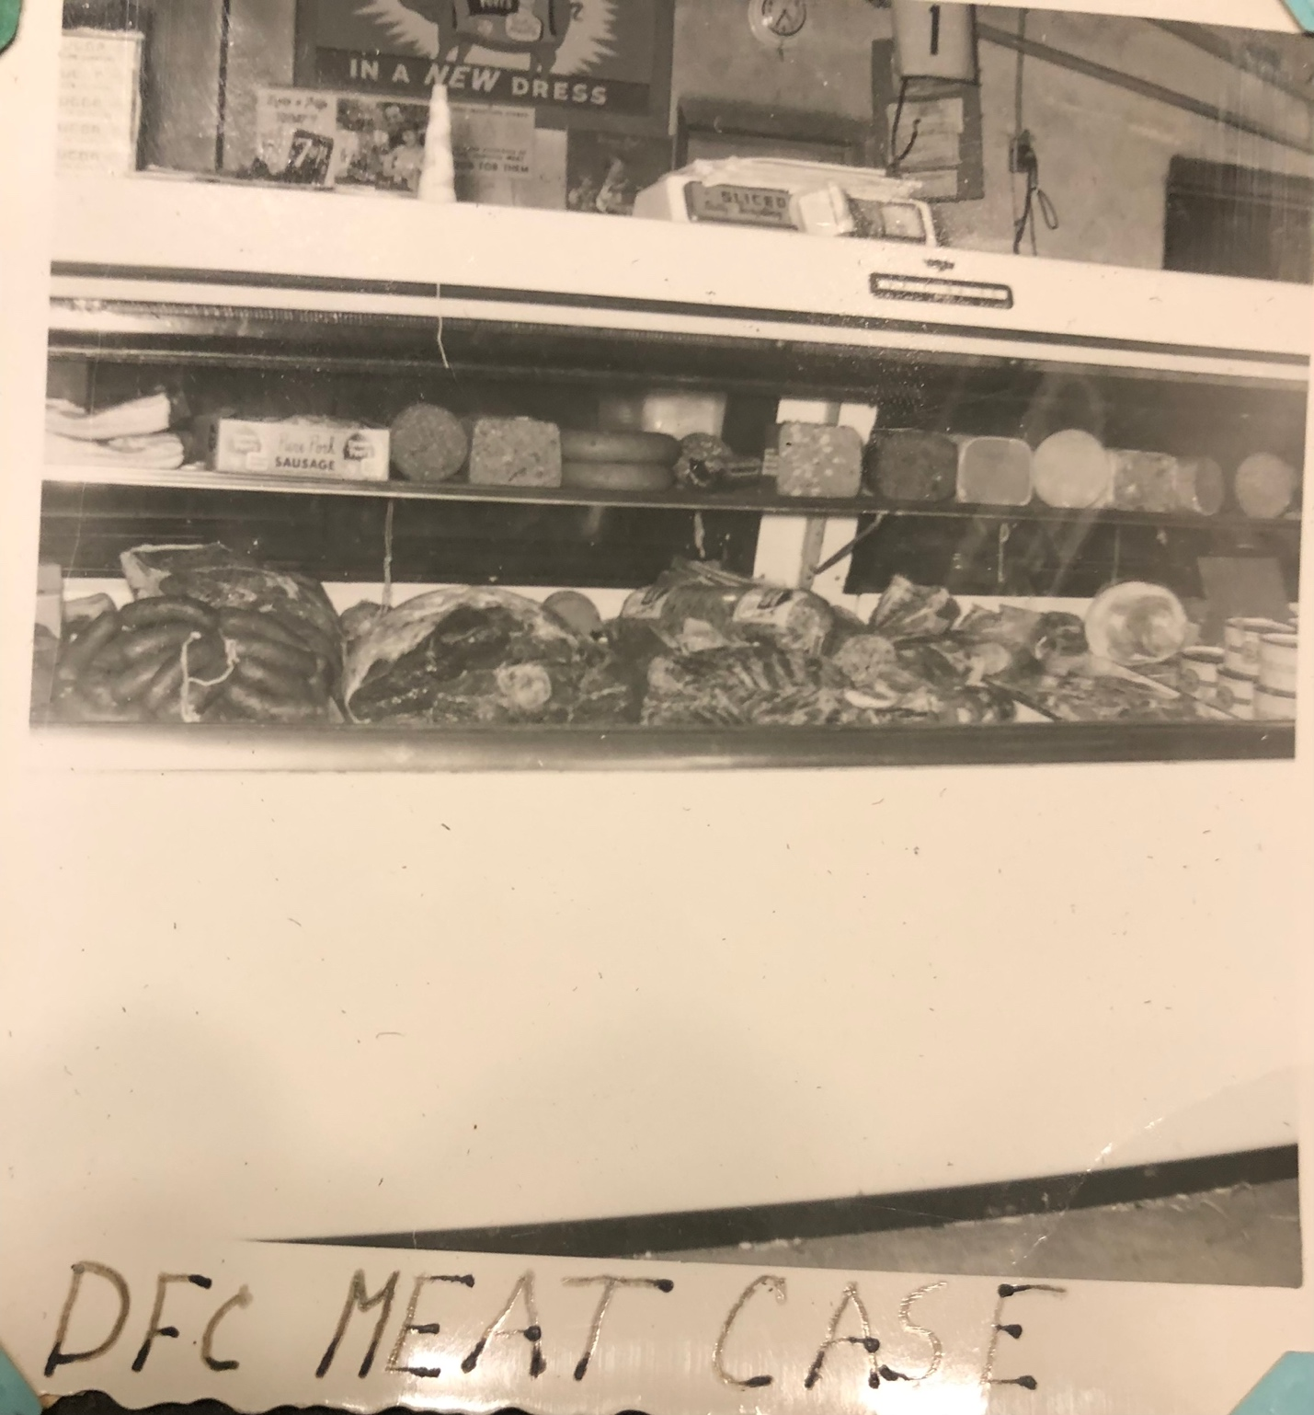

DFC MEAT CASE. Photograph. n.d. Davis Family Archives.

